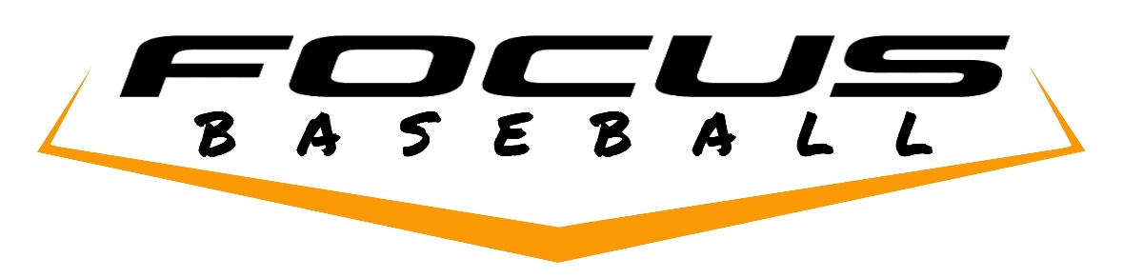

Below you will find details about our program,

During winter training and throughout the spring and summer, Focus instructors will train your player using positive coaching techniques, rooted in the fundamentals of baseball. Our program is a family-friendly, select organization which emphasizes both personal and athletic development. We will provide a fun, down-to-earth program where players and families can enjoy the game the way it was meant to be played. Focus teams will carry a roster of around fourteen players, and will play mostly in tournaments throughout the late winter, spring and summer. We will also scrimmage against other select teams during this time. The health of our players is extremely important, and our pitchers will be paced so that their arms will get adequate rest in between outings on the mound. A roster of this size allows us some flexibility with school and family schedules, etc.

Our Program is specifically designed to allow players to continue to play Little League baseball with their friends, we find that the relaxed atmosphere of Little League provides a place where our players can get reps in-between tournaments and our practices, and just plain have fun with their friends.

At Focus Baseball, we believe in coaching the whole person, not just the player. Your child will develop a personal relationship with our coaches and instructors which will influence their lives for years to come. Many other select programs only focus on winning, and while we also love to win, our goal is to prepare players for a lifetime of success, through hard work and learning. We also believe in balance, and that it is important for young players to take a break in the fall, try other sports, and most importantly, rest their arms. The majority of college and professional athletes participated in multiple sports throughout high school, and likewise we encourage your kids to be active; play Soccer, Ultimate Frisbee, Basketball, Ski, etc.

For our coaches, baseball instruction is what they live for—it is something that they have devoted their lives to and take very seriously. Their focus is not just on creating great athletes and helping them to fulfill their dreams, but also developing players into young adults with a strong moral code. At Focus Baseball, we are committed to growing a player's self-esteem and passion for baseball, while helping parents connect with their kids through the love of the game. At the end of the day, we love what we do, love seeing kids enjoy the game, and thrive on helping players push themselves to reach their goals while guiding them in setting new ones. This is what drives our coaches' commitment to provide high quality, progressive instruction.

**Outline of the Focus Practice Schedule**

**November and December**

**Strength and Conditioning** – twice weekly with Coach Moedritzer and/or Coach Korte likely one weekend morning and one weekday after school for 13u-16u, 12u will be once per week, usually in conjunction with a hitting or indoor fielding practice.

**Hitting, Positional and Glove Work Practices** - weekly with Coach Eder, Coach Lopez, Coach Gillis, Coach Perry, Coach Widley, Coach Clubine and other Instructors. (Additional private lessons are available directly through the coaches.)

**January and February**

**Strength and Conditioning** – 13-16u two times per week (12u once per week) with Coach Moedritzer and/or Coach Korte likely one weekend morning and one weekday after school usually in conjunction with a hitting or pitching practice.

**Indoor Hitting and Pitching Practices** - weekly with Coach Eder, Coach Lopez, Coach Gillis, Coach Perry, Coach Widley, Coach Clubine and other Instructors. (Additional private lessons are available directly through the coaches.)

**Outdoor Fielding Practices** -one to two times per week at a local field (North Seattle or Shoreline).

**March Through July**

**Practices and/or Scrimmages** –ranges from one to three days per week depending on scheduling and field availability

**Weekend Tournaments** – 13-16u teams will play approximately 8-10 tournaments (12u teams will play 3 tournaments). Some weekends outside of Holidays listed below will be left open without scheduled tournaments or events for family time/rest.

We believe that having regularly scheduled weekday practices throughout the spring is the best way to continue to develop players, playing in a select league along with tournaments leaves little room for practices and lessons, therefore at this time we do not plan to have any of our teams play in a select league this next season. Due to the shorter season the 16u team may play in League games instead of the full 8 tournaments.

**Holiday Policy**

We believe families should have time to do other things together during the season therefore we try to leave many of the holidays and school break periods open for Family time

**Player Fees**

Player fees for the 2025/2026 Focus Baseball Teams are All Inclusive and will be $2500/player for 12u and $4500/player for 13u-16u and fees includes the costs of coaches, training, fields, tournaments, scrimmages, uniforms and team training outfits.   Most of the tournaments will be local and will not require travel time of more than 90-minutes each way from the Seattle Area.  The families of the players will vote on the makeup of the remaining tournaments (local, travel by car, travel by plane, etc).     (12u is cheaper because they don’t train as many days per week and wont play in as many tournaments so they can concentrate on having their best Majors Little League Season)

**Please note: Individual family travel costs and coaches travel/lodging/food costs for all out of town tournaments are **not included** in the player fees, and will be divided equally between the families of the players attending.

Should your player be chosen to join our program. A $500 deposit is required to reserve a spot on the team, and will be deducted from the total player fee.  The balance of the player fee can either be paid in one lump sum, or broken into four payments of $1000 (or $500/month for 12u), due on the 1st of each month starting in November, with the final payment to be made on February 1st.    Deposits can be made via Venmo to @gclubine or via Zelle.

If your son has a friend he would like to invite, we are open to have them join us at our tryouts. We are looking for athletes with a strong drive to improve and succeed. Please have them email the Focus Director George Clubine at [Focusbaseballseattle@gmail.com](mailto:Focusbaseballseattle@gmail.com) or call 206-714-5356 if they are interested.

Focus Baseball is a completely not-for-profit organization. Every dollar from player fees goes directly into instruction, tournament fees, facility/field costs, uniforms etc. We believe that in order to have the best Instructors, coaches and consultants, it is necessary to pay them well, and have allocated 50% of player fees to go directly towards coaching and instructors, with another 25% allocated to pay for facilities and field space. The remaining 25% is allocated to cover uniforms, tournament fees, team equipment, insurance, etc.